create database Ecommerce;

use Ecommerce;

CREATE TABLE customers (

customer_id INT PRIMARY KEY,

name VARCHAR(100),

email VARCHAR(100),

address VARCHAR(255)

);

CREATE TABLE products (

product_id INT PRIMARY KEY,

name VARCHAR(100),

description TEXT,

price DECIMAL(10,2),

stockQuantity INT

);

CREATE TABLE cart (

cart_id INT PRIMARY KEY,

customer_id INT,

product_id INT,

quantity INT,

FOREIGN KEY (customer_id) REFERENCES customers(customer_id),

FOREIGN KEY (product_id) REFERENCES products(product_id)

);

CREATE TABLE orders (

order_id INT PRIMARY KEY,

customer_id INT,

order_date DATE,

total_price DECIMAL(10,2),

shipping_address VARCHAR(255),

FOREIGN KEY (customer_id) REFERENCES customers(customer_id)

);

CREATE TABLE order_items (

order_item_id INT PRIMARY KEY,

order_id INT,

product_id INT,

quantity INT,

item_amount DECIMAL(10,2),

FOREIGN KEY (order_id) REFERENCES orders(order_id),

FOREIGN KEY (product_id) REFERENCES products(product_id)

);

INSERT INTO customers VALUES

(1, 'John Doe', 'johndoe@example.com', '123 Main St, City'),

(2, 'Jane Smith', 'janesmith@example.com', '456 Elm St, Town'),

(3, 'Robert Johnson', 'robert@example.com', '789 Oak St, Village'),

(4, 'Sarah Brown', 'sarah@example.com', '101 Pine St, Suburb'),

(5, 'David Lee', 'david@example.com', '234 Cedar St, District'),

(6, 'Laura Hall', 'laura@example.com', '567 Birch St, County'),

(7, 'Michael Davis', 'michael@example.com', '890 Maple St, State'),

(8, 'Emma Wilson', 'emma@example.com', '321 Redwood St, Country'),

(9, 'William Taylor', 'william@example.com', '432 Spruce St, Province'),

(10, 'Olivia Adams', 'olivia@example.com', '765 Fir St, Territory');

INSERT INTO products VALUES

(1, 'Laptop', 'High-performance laptop', 800.00, 10),

(2, 'Smartphone', 'Latest smartphone', 600.00, 15),

(3, 'Tablet', 'Portable tablet', 300.00, 20),

(4, 'Headphones', 'Noise-canceling', 150.00, 30),

(5, 'TV', '4K Smart TV', 900.00, 5),

(6, 'Coffee Maker', 'Automatic coffee maker', 50.00, 25),

(7, 'Refrigerator', 'Energy-efficient', 700.00, 10),

(8, 'Microwave Oven', 'Countertop microwave', 80.00, 15),

(9, 'Blender', 'High-speed blender', 70.00, 20),

(10, 'Vacuum Cleaner', 'Bagless vacuum cleaner', 120.00, 10);

INSERT INTO orders VALUES

(1, 1, '2023-01-05', 1200.00, '123 Main St, City'),

(2, 2, '2023-02-10', 900.00, '456 Elm St, Town'),

(3, 3, '2023-03-15', 300.00, '789 Oak St, Village'),

(4, 4, '2023-04-20', 150.00, '101 Pine St, Suburb'),

(5, 5, '2023-05-25', 1800.00, '234 Cedar St, District'),

(6, 6, '2023-06-30', 400.00, '567 Birch St, County'),

(7, 7, '2023-07-05', 700.00, '890 Maple St, State'),

(8, 8, '2023-08-10', 160.00, '321 Redwood St, Country'),

(9, 9, '2023-09-15', 140.00, '432 Spruce St, Province'),

(10, 10, '2023-10-20', 1400.00, '765 Fir St, Territory');

INSERT INTO order_items VALUES

(1, 1, 1, 2, 1600.00),

(2, 1, 3, 1, 300.00),

(3, 2, 2, 3, 1800.00),

(4, 3, 5, 2, 1800.00),

(5, 4, 4, 4, 600.00),

(6, 4, 6, 1, 50.00),

(7, 5, 1, 1, 800.00),

(8, 5, 2, 2, 1200.00),

(9, 6, 10, 2, 240.00),

(10, 6, 9, 3, 210.00);

INSERT INTO cart VALUES

(1, 1, 1, 2),

(2, 1, 3, 1),

(3, 2, 2, 3),

(4, 3, 4, 4),

(5, 3, 5, 2),

(6, 4, 6, 1),

(7, 5, 1, 1),

(8, 6, 10, 2),

(9, 6, 9, 3),

(10, 7, 7, 2);

1.Update refrigerator product price to 800.

UPDATE products SET price = 800.00 WHERE name = 'Refrigerator';

2. Remove all cart items for a specific customer.

DELETE FROM cart WHERE customer_id = 3;

3. Retrieve Products Priced Below $100.

SELECT * FROM products WHERE price < 100;

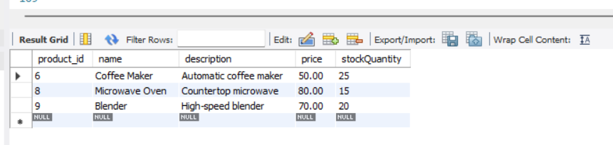

4. Find Products with Stock Quantity Greater Than 5.

SELECT * FROM products WHERE stockQuantity > 5;

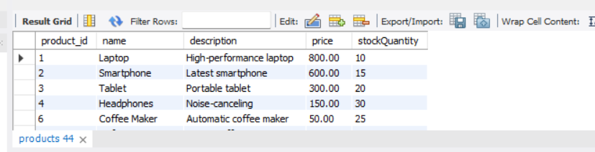

5. Retrieve Orders with Total Amount Between $500 and $1000.

SELECT * FROM orders WHERE total_price BETWEEN 500 AND 1000;

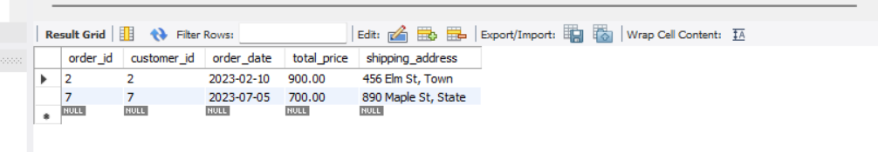

6. Find Products which name end with letter ‘r’.

SELECT * FROM products WHERE name LIKE '%r';

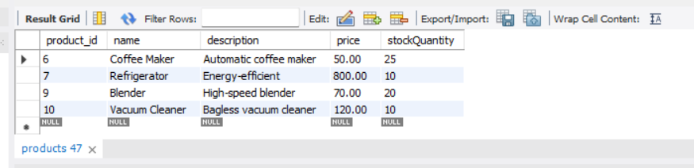

7. Retrieve Cart Items for Customer 5.

SELECT * FROM cart WHERE customer_id = 5;

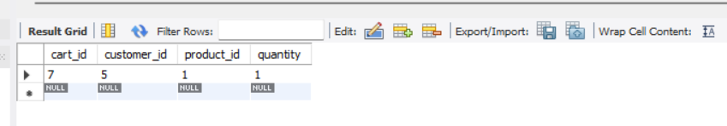

8. Find Customers Who Placed Orders in 2023.

SELECT DISTINCT c.*

FROM customers c

JOIN orders o ON c.customer_id = o.customer_id

WHERE YEAR(order_date) = 2023;

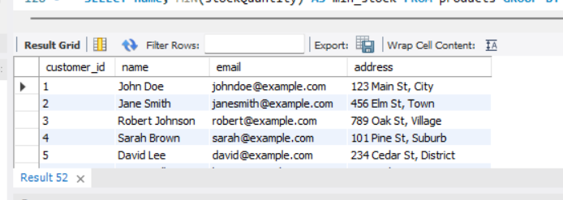

9. Determine the Minimum Stock Quantity for Each Product Category.

SELECT name, MIN(stockQuantity) AS min_stock FROM products GROUP BY name;

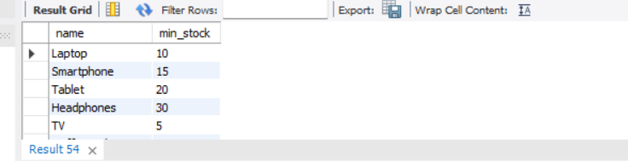

10. Calculate the Total Amount Spent by Each Customer.

SELECT c.customer_id, c.name, SUM(o.total_price) AS total_spent

FROM customers c

JOIN orders o ON c.customer_id = o.customer_id

GROUP BY c.customer_id;

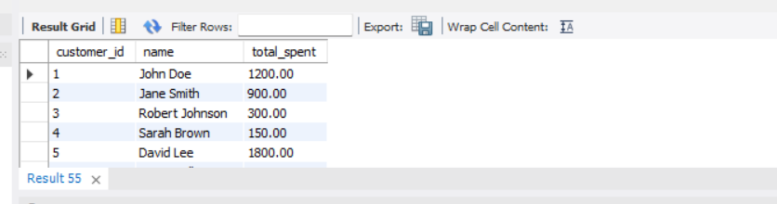

11. Find the Average Order Amount for Each Customer.

SELECT c.customer_id, c.name, AVG(o.total_price) AS avg_order_amount

FROM customers c

JOIN orders o ON c.customer_id = o.customer_id

GROUP BY c.customer_id;

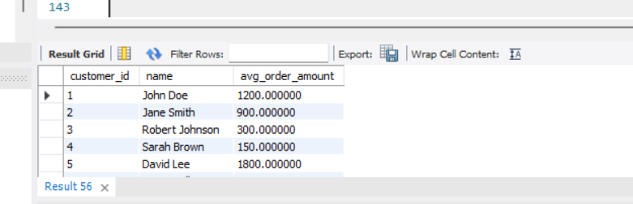

12. Count the Number of Orders Placed by Each Customer.

SELECT customer_id, COUNT(*) AS order_count

FROM orders

GROUP BY customer_id;

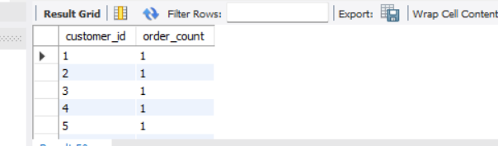

13. Find the Maximum Order Amount for Each Customer

SELECT customer_id, MAX(total_price) AS max_order

FROM orders

GROUP BY customer_id;

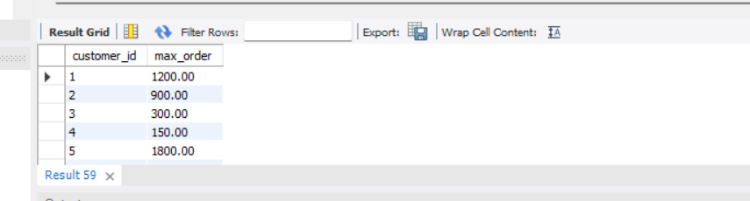

14. Get Customers Who Placed Orders Totaling Over $1000.

SELECT c.customer_id, c.name, SUM(o.total_price) AS total

FROM customers c

JOIN orders o ON c.customer_id = o.customer_id

GROUP BY c.customer_id

HAVING total > 1000;

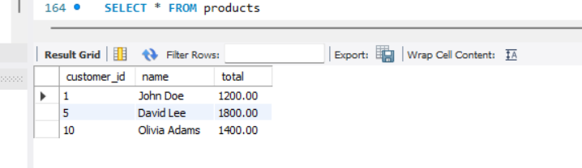

15. Subquery to Find Products Not in the Cart

WHERE product_id NOT IN (SELECT product_id FROM cart);

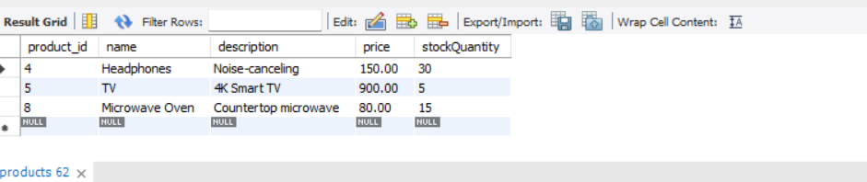

16. Subquery to Find Customers Who Haven't Placed Orders.

SELECT * FROM customers

WHERE customer_id NOT IN (SELECT customer_id FROM orders);

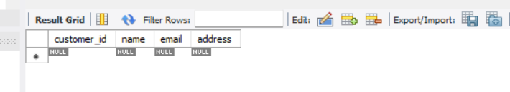

17. Subquery to Calculate the Percentage of Total Revenue for a Product.

SELECT

product_id,

ROUND(SUM(item_amount) / (SELECT SUM(item_amount) FROM order_items) * 100, 2) AS revenue_percentage

FROM order_items

WHERE product_id = 1

GROUP BY product_id;

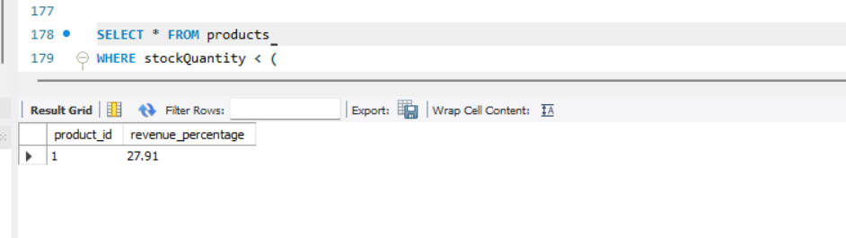

18. Subquery to Find Products with Low Stock.  
SELECT * FROM products

WHERE stockQuantity < (

SELECT AVG(stockQuantity) FROM products

);

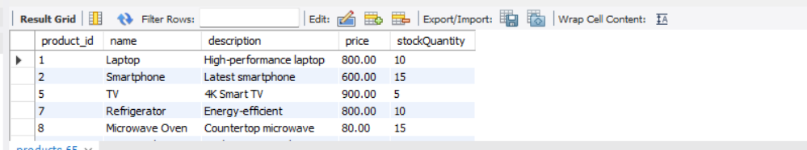

19. Subquery to Find Customers Who Placed High-Value Orders.

SELECT * FROM customers

WHERE customer_id IN (

SELECT customer_id

FROM orders

WHERE total_price > 1000

);

